## CP

The counterplan is this picture.

Resolved:

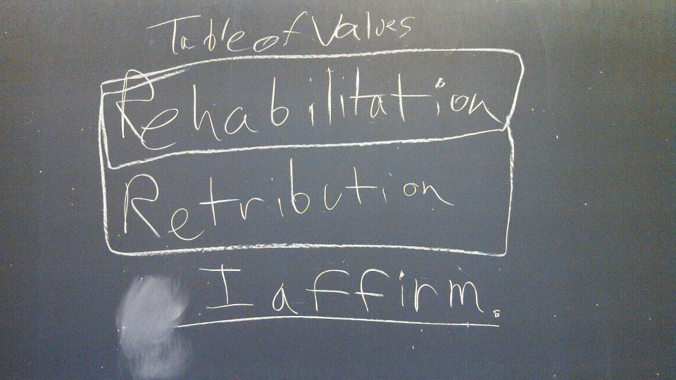

The counter-plan is competitive because the neg does not advocate the words used in the resolution but instead uses pictures to describe the same action. Any permutation still links to the net benefit.

The counter-plan solves 100% of the aff because it depicts the same action the affirmative advocates while avoiding the rhetoric used.

## Environment NB

Reliance on the alphabet for communication suppresses right-brain thought.

Neurosurgeon Leonard **Shlain 98** writes[1]

Aside from the obvious benefits that derived from their ease of use, alphabets produced a subtle change in cognition that redirected human thinking. For sophisticated neurolinguistic reasons the early practitioners could not have known, alphabets reinforced only half of the dual strategy that humans had evolved to survive. As we have seen, this strategy had three components: left brain/right brain, cone/rod, and right hand/left hand. Each tripartite half of this duality perceived and reacted to the world in a different way; a unified response emerged only when both complementary halves were used. **All forms of writing increase the left brain's dominance over the right.** As civilization progressed from image-based communication, such as pictographs and hieroglyphs, to non-iconic forms, such as cuneiform, written communication became more left-brain oriented. **An alphabet, being the most abstract form of writing, enhances left-brain values the most.** Each letter stands only for a singular sound; meaning emerges only when letters are strung together in a row. Unlike icons, which often evolved from images of things, an alphabetic word bears no resemblance to the object or action it symbolizes. Nowhere in the word dog can we discern a dog. There remain some trace correlations, as with the word water, which begins with the letter w. The ancient Egyptians created a hieroglyph for water that resembles our letter w and to indicate water on a map, or in a cartoon, we still use a series of wavy lines. This iconic symbol for water became the alphabetic letter w and is a component of many words associated with the liquid state of matter (e.g., wet, wave, wash, wade, wallow, winnow, womb, and woman). However, we no longer connect the letter w with water directly. When we see w in print as part of a word, the brain issues complex directions that instruct the lips to purse so that we can pronounce the phonetic sound of w. **Alphabets have long divorced themselves from the images of concrete things.** They have washed out of the written language iconic patterns that were apparent in earlier forms of writing. All that remains are letters that stand starkly like rows of pier posts at ebb tide. The versatility of letters becomes evident when they are placed in regular, linear, consensually agreed upon arrangements. Aligning three letters to spell d-o-g results in the English reader instantly seeing a dog in the mind's eye. Yet the mental image of a dog was once attached only to a real dog, or to the invisible spoken word, dog. The induction of any member of society (usually a young child) into alphabet arcana numbs her to the fact that she supplants all-at-once gestalt perception with a new, unnatural, highly abstract one-at-a-time cognition. **In this fashion, alphabets subliminally elevated**, within each alphabet user, **the influence of the left hemisphere at the expense of the right.**

Right-brain thought is key to preserve the ecosystem. Left-brain dominance must be challenged to avoid extinction. **Reuther 89** writes[2]

The notion of dominating the universe from a position of autonomy is an illusion of alienated consciousness. **We have only two** real **options:** either to learn to use our intelligence to **become servants of** the survival and cultivation of **nature or** to **lose our own life-support system in a**n increasingly **poisoned earth.** This conversion of our intelligence to the earth will demand a new form of human intelligence. **The dominant** white western **male rationality has been based on** linear, **dichotomized** thought **patterns** that divide reality into dualism: **one is good and the other bad,** one superior and the other inferior, **one should dominate and the other should be** eliminated or **suppressed. The biological base of these patterns is specialization in left-brain, rational functions in a way that suppresses the right-brain, relational sense.** This one-sided brain development seems more dominant in males than in females, possibly because of later verbal development in males. This biological tendency has been exaggerated by socialization into dominant and subordinate social roles. Dominant social roles exaggerate linear, dichotomized thinking and prevent the development of culture that would correct this bias by integrating the relational side. Women and other subordinate groups, moreover, have had their rational capacities suppressed through denial of education and leadership experience and so tend to be perceived as having primarily intuitive and affective patterns of thought. Thus socialization in power and powerlessness distorts integration further and creates what appears to be dichotomized personality cultures of men and women, that is, masculinity and femininity. What we must now realize is that the patterns of rationality of **left-brain specialization** are, in many ways, ecologically dysfunctional. Far from this rationality being the mental counterpart of "natural law," it **screens out much of reality as "irrelevant" to science** and reduces scientific knowledge to a narrow spectrum fitted to dominance and control. **But the systems it sets up are ecologically dysfunctional because they fail to see** the **larger relational patterns** within which particular "facts" stand. This rationality tends toward monolithic systems of use of nature. Linear thinking, for example, directs agriculture, or even decorative planting, toward long rows of the same plant. This magnifies the plants' vulnerability to disease. Humans then compensate with chemical sprays, which in turn send a ripple effect of poisons through the whole ecological system. Nature, by contrast, diffuses and intersperses plants, so that each balances and corrects the vulnerabilities of the other. The inability to see the forest for the trees is typical of linear thinking. Linear thinking simplifies, dichotomizes, focuses on parts, and fails to see the larger relationality and interdependence. Ecological thinking demands a different kind of rationality, one that integrates left-brain linear thought and right-brain spatial and relational thought. **One has to disrupt the linear concept** of order **to create a different** kind of **order** that is truly **the way nature "orders,"** that is, balances and harmonizes, but that appears very "disorderly" to the linear, rational mind.

## Patriarchy NB

The rise of patriarchy comes hand-in-hand with the rise of the alphabet.

Neurosurgeon Leonard **Shlain 98** writes[3]

The proposition that the alphabet has hindered women's aspirations and accomplishments seems, at first glance, to be antithetical to historical facts. Western society, based on the rule of law and constitutional government, has increasingly affirmed the dignity of the individual, and in the last few centuries Western women have won rights and privileges not available in many other cultures. Most people believe that the benefits that have accrued to women are due primarily to a high level of education among the populace. But a study of the origins of writing in less complex times thousands of years ago reveals how writing, first, and then **the alphabet**, **altered the balance of power to women's detriment.** Anthropological **studies of non-literate** agricultural **societies show that**, for the majority, **relations between men and women have been more egalitarian than in more developed societies.** Researchers have never proven beyond dispute that there were ever societies in which women had power and influence greater than or even equal to that of men. Yet, **a diverse variety of preliterate** agrarian **cultures**—the Iroquois and the Hopi in North America, the inhabitants of Polynesia, the African !Kung, and numerous others around the world—**had** and continue to have considerable **harmony between the sexes.** Anthropologist Claude Levi-Strauss was one of the very few scholars to challenge literacy's worth. There is one fact that can be established: **the only phenomenon which, always and in all parts of the world, seems** to be **linked with the appearance of writing** ... **is the establishment of hierarch[y]**ical societies, consisting of masters and slaves, and where one part of the population is made to work for the other part. Literacy has promoted the subjugation of women by men throughout all but the very recent history of the West. **Misogyny and patriarchy rise and fall with the fortunes of the alphabetic written word.**

Our patriarchal culture must be challenged to prevent extinction.

**Spretnak 89** writes[4]

**Most men in our patriarchal culture are still acting out old patterns** that are **radically inappropriate for the nuclear age. To prove dominance and control, to distance one’s character from that of women, to survive the toughest violent initiation,** to shed the sacred blood of the hero, to collaborate with death in order to hold it at bay – **all of these patriarchal pressures** on men **have traditionally reached resolution** in a ritual fashion **on the battlefield. But there is no longer any battlefield.** Does anyone seriously believe that if a nuclear power were losing a crucial, large-scale conventional war it would refrain from using its multiple-warhead nuclear missiles because of some diplomatic agreement? **The military theater of a nuclear exchange today would extend**, instantly or eventually, **to all living things**, all the air, all the soil, all the water. If we believe that war is a “necessary evil,” that patriarchal assumptions are simply “human nature,” then we are locked into a lie, paralyzed. **The ultimate result of** unchecked terminal **patriarchy will be nuclear holocaust.**

## Bostrom

Any risk of extinction comes first. Nick **Bostrom 11**[5]

Even if we use the most conservative of these estimates, which entirely ignores the possibility of space colonization and software minds, we find that **the expected loss of an existential catastrophe is greater than** the value of 1018 human lives.  This implies that the expected value of reducing existential risk by a mere one millionth of one percentage point is at least ten times the value of a billion human lives.  The more technologically comprehensive estimate of 1054 human-brain-emulation subjective life-years (or **1052 lives** of ordinary length) makes the same point even more starkly.  **Even if we give this** allegedly **lower bound** on the cumulative output potential of a technologically mature civilization **a mere 1% chance of being correct, we find that** the expected value of **reducing existential risk by a mere one billionth of one billionth of one percent**age point **is worth a hundred billion times** as much as **a billion human lives.**

## Virtue Ethics Turn

Written language fosters vice, not virtue. **Socrates -370** ~~writes~~ says[6]

The story goes that Thamus said much to Theuth, both for and against each art, which it would take too long to repeat. But when they came to writing, Theuth said: “O King, here is something that, once learned, will make the Egyptians wiser and will improve their memory; I have discovered a potion for memory and for wisdom.” Thamus, however, replied: “O most expert Theuth, one man can give birth to the elements of an art, but only another can judge how they can benefit or harm those who will use them. And now, since you are the father of **writing**, your affection for it has made you describe its effects as the opposite of what they really are. In fact, it **will introduce forgetfulness into the soul** of those who learn it: **they will not practice using their memory because they will put** their **trust** in **writing**, which is external and depends on signs that belong to others, instead of trying to remember from the inside, completely on their own. **You have not discovered a potion for remembering, but for reminding;** you provide **your students** with the appearance of wisdom, not with its reality. Your invention **will** enable them to **hear many things without being** properly **taught**, and they will imagine that they have come to know much while for the most part they will know nothing. And **they will be difficult to get along with, since they will** merely **appear** to be **wise instead of really being so.”**

1. Dr. Leonard Shlain is a neurosurgeon at California-Pacific Medical Center and contributor to The Encyclopedia of Creativity, The Alphabet Versus The Goddess: The Conflict Between Word and Image, 1998, pg. 66-8
2. Rosemary Radford Reuther, Professor of Feminist Theology at Pacific School of Religion, 1989, “Toward an Ecological-Feminist Theology of Nature” in Healing the Wounds: the Promise of Ecofeminism ed. Judith Plant p. 147-150
3. Dr. Leonard Shlain is a neurosurgeon at California-Pacific Medical Center and contributor to The Encyclopedia of Creativity, The Alphabet Versus The Goddess: The Conflict Between Word and Image, 1998, pg. 66-8
4. MA in English from Berkely [Charlene Spretnak, Exposing Nuclear Phallacies, Editor, Diana EH Russel, p.60] 1989
5. Nick Bostrom (Future of Humanity Institute, Oxford Martin School & Faculty of Philosophy, University of Oxford), “THE CONCEPT OF EXISTENTIAL RISK”, 2011

   <http://www.existential-risk.org/concept.html>
6. Socrates (469-399 BCE) was a Greek Philosopher who thought and taught through argumentative dialogue, or dialectic. Socrates did not write down any of his thoughts, however his dialogues were recorded by his student and protégé, the philosopher Plato (428 – 347 BCE). Here Socrates discusses the deficiencies of writing. Cerca 370 BCE. Athens. <http://www.laphamsquarterly.org/voices-in-time/unintended-consequence.php>